**WebSocketSDK(PHP) Sample for Windows**

(M50, M60, M70)

2023/3/30

1. **System Requerements**

|  |  |  |
| --- | --- | --- |
| **Item** | **Supported** | **Tested** |
| OS | Win7 / Windows 2012 Server, or Later | Win10 |
| IIS | IIS 8, or Later | IIS 8, IIS 10 |
| Internet Explorer | IE10, IE11 | IE11 |
| PHP | PHP7 or Later | PHP8 |
| M50, M60, M70 FW | v2.2.6 20151027 or Later | v2.2.9 |

1. **Server Configuration**

PHP webserver can be configured in various way, and there are many integrated PHP webserver applications such as [XAMPP](https://serverguy.com/servers/php-servers/#xampp), [WAMP](https://serverguy.com/servers/php-servers/#wamp), etc.

Developers can install any PHP webserver which they prefer, but in this document we only use PHP8 from [PHP Web site](https://www.php.net/downloads.php) and it’s embedded web server.

* **Install PHP**

Download latest version of PHP from [PHP Web site](https://www.php.net/downloads.php).

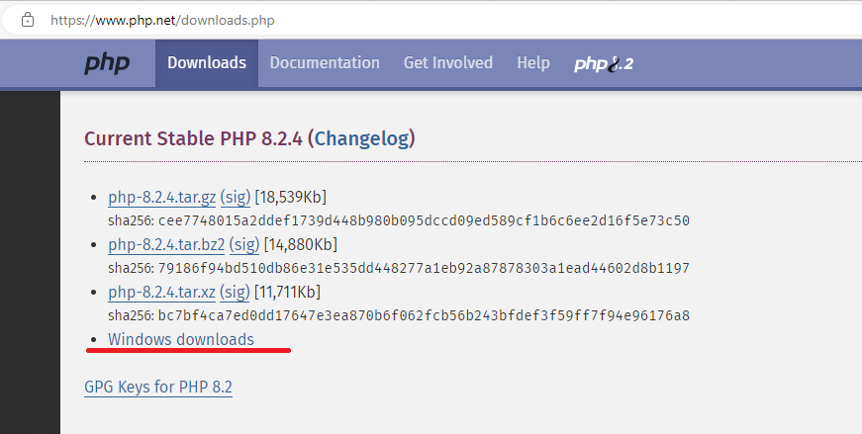

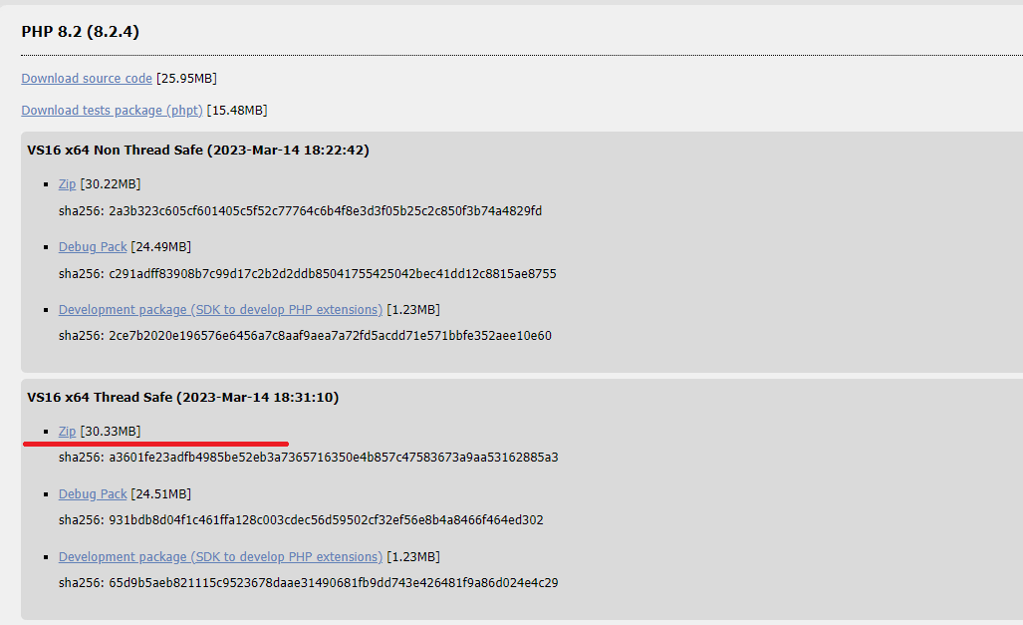

Extract PHP to certain directory(Ex: C:\PHP)

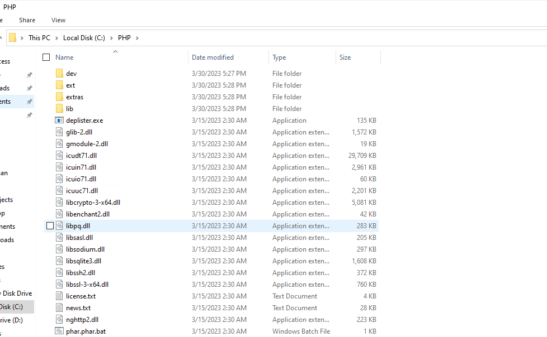

Rename php.ini-development or php.ini-production to php.ini, and open php.ini with notepad.

Set extension directory and enable following extensions.

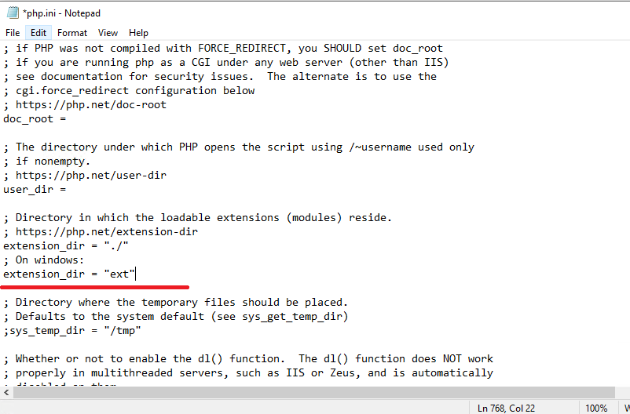

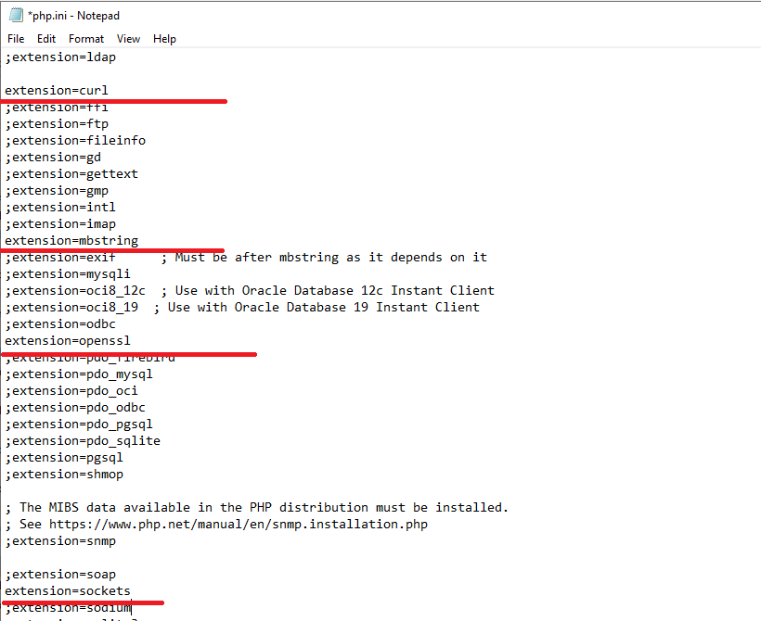

Add PHP installation directory to system PATH variable.

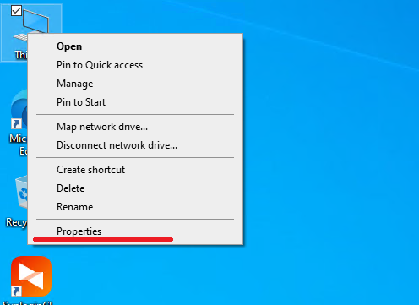

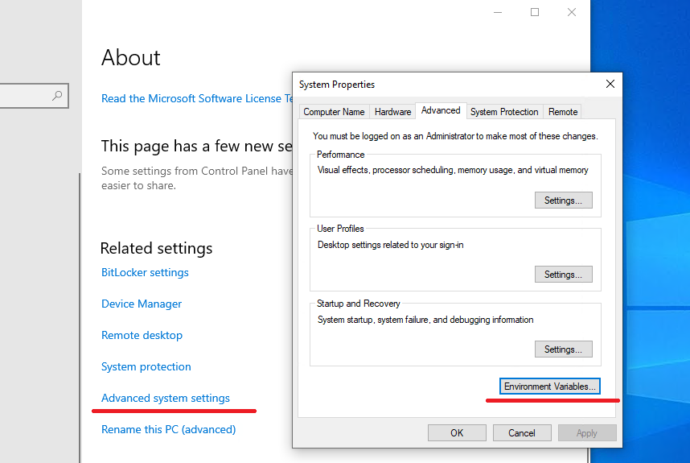

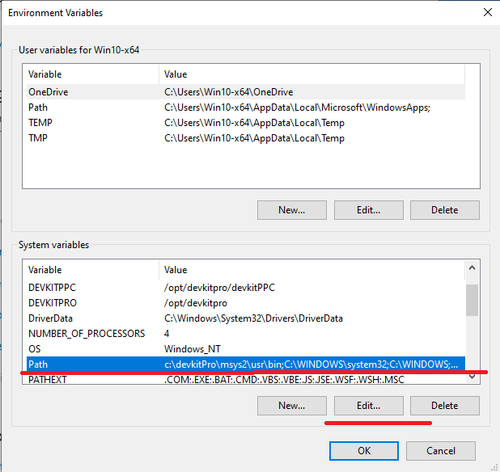

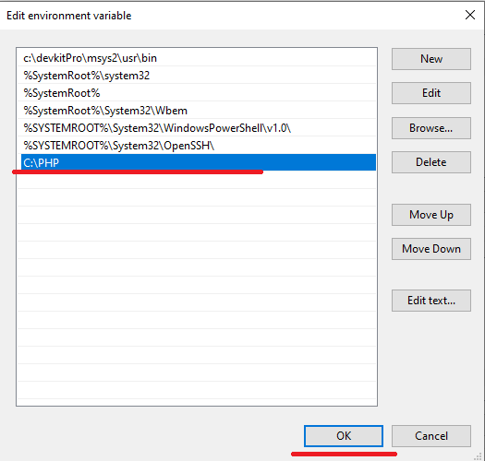

**NOTE: After setting system environment variable, please reboot your computer to make it work.**

**NOTE: If visual studio 2017 or later version is not installed on your computer, please download visual studio redistributable package from** [Latest supported Visual C++ Redistributable downloads | Microsoft Learn](https://learn.microsoft.com/en-US/cpp/windows/latest-supported-vc-redist?view=msvc-170) **and install it.**

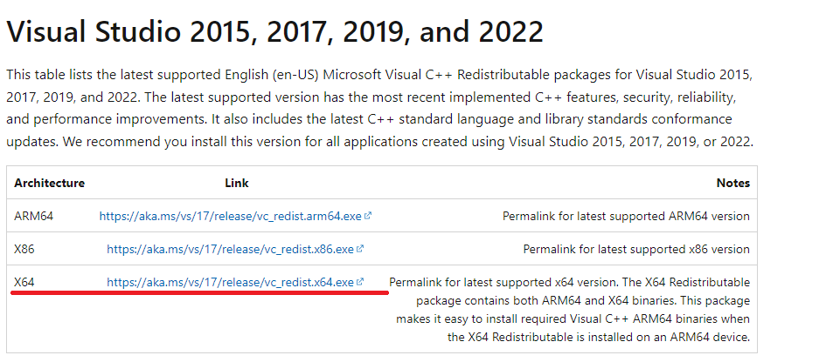

Open command prompt and to check if PHP is successfully installed on your computer.

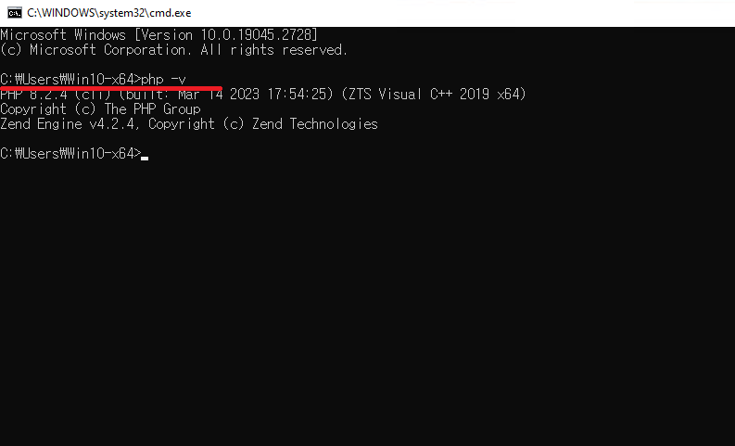

* **Install PHP Composer**

Install PHP composer as described in <https://www.geeksforgeeks.org/how-to-install-php-composer-on-windows/>.

1. **Sample Configuration and run server**

* **Download workerman package.**

Open windows command prompt and move to *WebSocketSDK_PHP* directory and run following command.  
***composer require walkor/workerman***

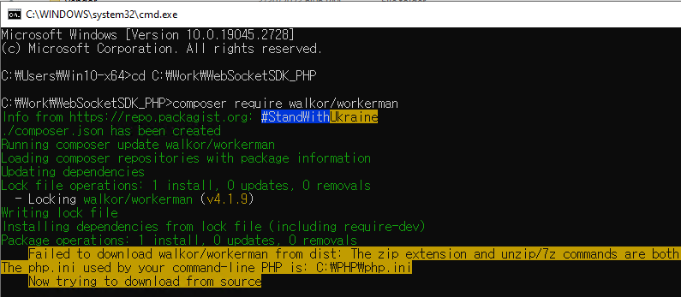

**NOTE: To install workerman package you need to install Git first.**

**Git can be downloaded from** [Git - Downloads (git-scm.com)](https://git-scm.com/downloads)**.**

* **Set websocket server port.**

Open *WebSocketSDK_PHP/ config.inc.php* file and set websocket server port.  
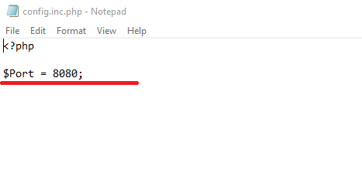

* **Run PHP websocket server.**

Open command prompt and move to *WebSocketSDK_PHP* directory and run following command.

***php ws_server.php***

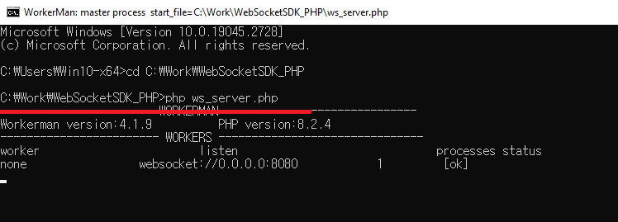

* **Run PHP web server.**

Open command prompt and move to *WebSocketSDK_PHP /wwwroot* directory and run following command.

***php -S 0.0.0.0:[PORT]***

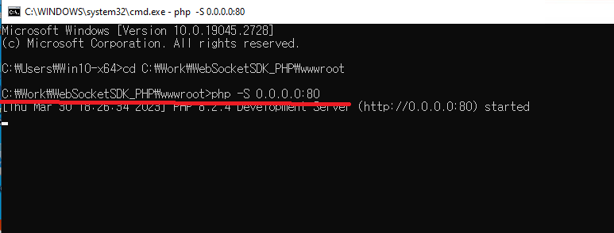

1. **Prepare Firmware**
2. Set Active Client Mode.

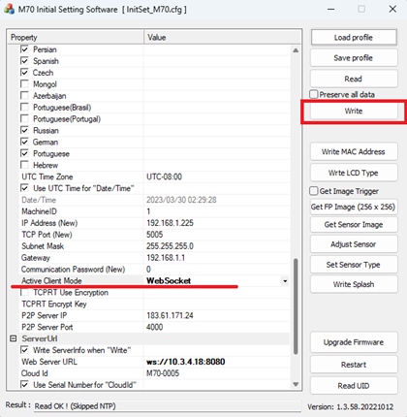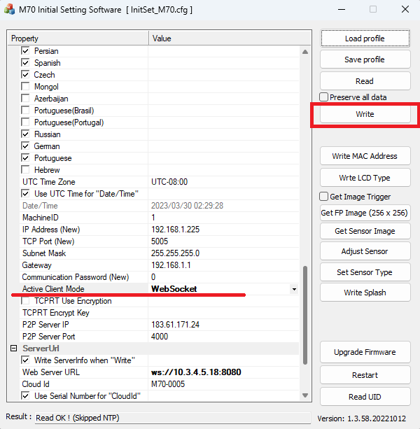

1. Set Device Serial Number

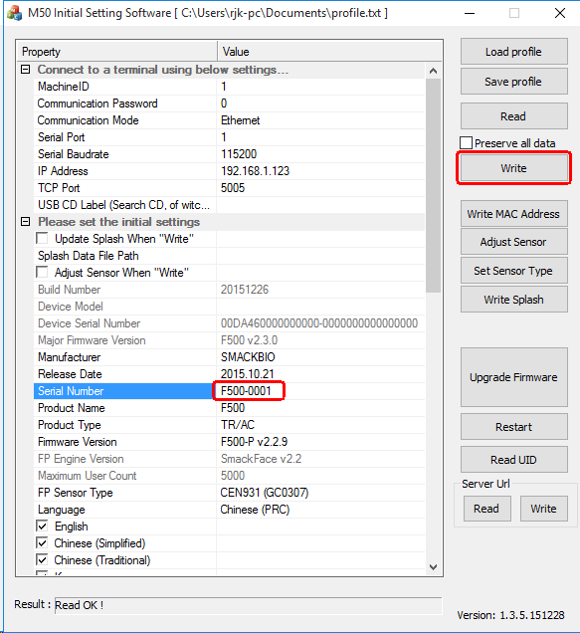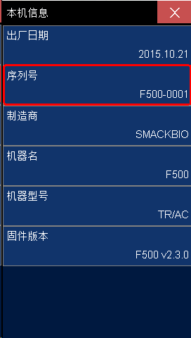

1. Set WebServer Address.

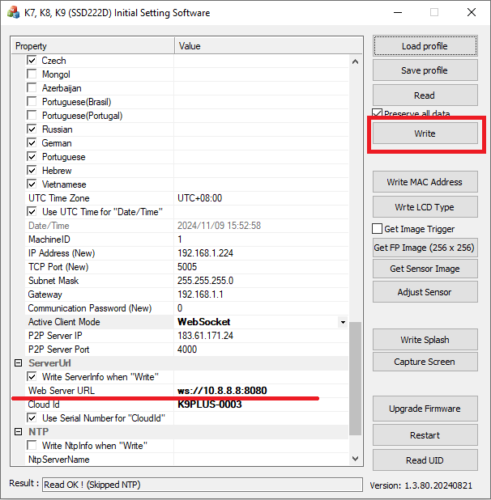

1. Restart the terminal.
2. **Open your web browser and open your sample home page** [**http://localhost**](http://localhost)**.**